***Masala Khichdi***

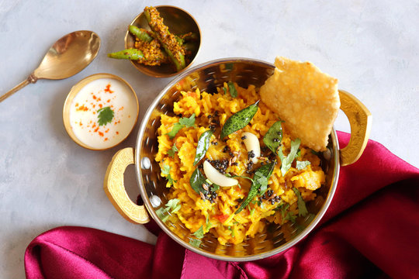

***Information:-***

Masala Khichdi is a delicious and hearty dish that is made by cooking rice, lentils, and vegetables together with a fragrant blend of spices. This dish is popular all over India and is often enjoyed as a comfort food. The rice and lentils provide a good source of carbohydrates and protein, while the vegetables add fiber, vitamins, and minerals. The spices used in Masala Khichdi, such as cumin, coriander, turmeric, and garam masala, not only add a rich depth of flavor but also offer various health benefits. For instance, turmeric is known for its anti-inflammatory properties, while cumin aids digestion. Masala Khichdi can be served as a main dish for lunch or dinner, or as a filling breakfast option. It is a versatile dish that can be easily customized by adding your favorite vegetables or adjusting the level of spiciness to your taste.

***Nutritional Information:-***

* Calories: 225 kcal
* Protein: 9 g
* Carbohydrates: 42 g
* Fat: 2 g
* Fiber: 6 g
* Sugar: 2 g
* Sodium: 310 mg

Masala Khichdi is a healthy and balanced meal that provides a good source of complex carbohydrates, protein, fiber, and essential vitamins and minerals. It is also low in fat and sugar, making it a great option for those who are watching their weight or blood sugar levels. The exact nutritional value of Masala Khichdi may vary depending on the specific recipe and the types and quantities of vegetables used.

***Ingredients:***

* 1 cup of basmati rice
* 1/2 cup of split yellow mung dal (lentils)
* 2 tbsp of ghee or oil
* 1 tsp of cumin seeds
* 1 tsp of mustard seeds
* 1/4 tsp of asafoetida (hing)
* 1 onion, chopped
* 1 tomato, chopped
* 1 cup of mixed vegetables (such as peas, carrots, cauliflower, and bell peppers), chopped
* 1 tsp of ginger paste
* 1 tsp of garlic paste
* 1 tsp of turmeric powder
* 1 tsp of coriander powder
* 1 tsp of cumin powder
* 1 tsp of garam masala
* Salt to taste
* 4 cups of water
* Coriander leaves for garnishing

***Instructions:***

1. Rinse the rice and mung dal in water and soak them together for at least 30 minutes.
2. In a pressure cooker or a heavy-bottomed pot, heat ghee or oil over medium heat.
3. Add cumin seeds, mustard seeds, and asafoetida. Let them sizzle.
4. Add chopped onions and sauté until they turn translucent.
5. Add chopped tomatoes and sauté until they turn soft and mushy.
6. Add chopped mixed vegetables, ginger paste, garlic paste, turmeric powder, coriander powder, cumin powder, garam masala, and salt. Mix well and sauté for a minute.
7. Drain the soaked rice and mung dal and add them to the pot. Mix well with the vegetables.
8. Add 4 cups of water and stir everything together.
9. If using a pressure cooker, close the lid and cook for 3-4 whistles on high heat. If using a pot, cover it with a lid and cook until the rice and lentils are soft and fully cooked.
10. Once done, turn off the heat and let it rest for 5 minutes.
11. Open the lid and fluff the khichdi with a fork.
12. Garnish with chopped coriander leaves and serve hot with yogurt or pickle.

Enjoy your delicious and aromatic Masala Khichdi!